Unit-IV

Insertion Sort Algorithm:
The working procedure of insertion sort is also simple. This article will be very helpful and interesting to students as they might face insertion sort as a question in their examinations. So, it is important to discuss the topic.
Insertion sort works similar to the sorting of playing cards in hands. It is assumed that the first card is already sorted in the card game, and then we select an unsorted card. If the selected unsorted card is greater than the first card, it will be placed at the right side; otherwise, it will be placed at the left side. Similarly, all unsorted cards are taken and put in their exact place.
The same approach is applied in insertion sort. The idea behind the insertion sort is that first take one element, iterate it through the sorted array. Although it is simple to use, it is not appropriate for large data sets as the time complexity of insertion sort in the average case and worst case is O(n²), where n is the number of items. Insertion sort is less efficient than the other sorting algorithms like heap sort, quick sort, merge sort, etc.
Insertion sort has various advantages such as -
- Simple implementation
- Efficient for small data sets
- Adaptive, i.e., it is appropriate for data sets that are already substantially sorted.
Now, let's see the algorithm of insertion sort.

Algorithm
The simple steps of achieving the insertion sort are listed as follows -
Step 1 - If the element is the first element, assume that it is already sorted. Return 1.
Step2 - Pick the next element, and store it separately in a key.
Step3 - Now, compare the key with all elements in the sorted array.
Step 4 - If the element in the sorted array is smaller than the current element, then move to the next element. Else, shift greater elements in the array towards the right.
Step 5 - Insert the value.
Step 6 - Repeat until the array is sorted.

Working of Insertion sort Algorithm
Now, let's see the working of the insertion sort Algorithm.
To understand the working of the insertion sort algorithm, let's take an unsorted array. It will be easier to understand the insertion sort via an example.
Let the elements of array are -

Initially, the first two elements are compared in insertion sort.

Here, 31 is greater than 12. That means both elements are already in ascending order. So, for now, 12 is stored in a sorted sub-array.

Now, move to the next two elements and compare them.

Here, 25 is smaller than 31. So, 31 is not at correct position. Now, swap 31 with 25. Along with swapping, insertion sort will also check it with all elements in the sorted array.
For now, the sorted array has only one element, i.e. 12. So, 25 is greater than 12. Hence, the sorted array remains sorted after swapping.

Now, two elements in the sorted array are 12 and 25. Move forward to the next elements that are 31 and 8.

Both 31 and 8 are not sorted. So, swap them.

After swapping, elements 25 and 8 are unsorted.

So, swap them.

Now, elements 12 and 8 are unsorted.

So, swap them too.

Now, the sorted array has three items that are 8, 12 and 25. Move to the next items that are 31 and 32.

The working procedure of insertion sort is also simple. This article will be very helpful and interesting to students as they might face insertion sort as a question in their examinations. So, it is important to discuss the topic.
Insertion sort works similar to the sorting of playing cards in hands. It is assumed that the first card is already sorted in the card game, and then we select an unsorted card. If the selected unsorted card is greater than the first card, it will be placed at the right side; otherwise, it will be placed at the left side. Similarly, all unsorted cards are taken and put in their exact place.
The same approach is applied in insertion sort. The idea behind the insertion sort is that first take one element, iterate it through the sorted array. Although it is simple to use, it is not appropriate for large data sets as the time complexity of insertion sort in the average case and worst case is O(n²), where n is the number of items. Insertion sort is less efficient than the other sorting algorithms like heap sort, quick sort, merge sort, etc.
Insertion sort has various advantages such as -
- Simple implementation
- Efficient for small data sets
- Adaptive, i.e., it is appropriate for data sets that are already substantially sorted.
Now, let's see the algorithm of insertion sort.

Algorithm
The simple steps of achieving the insertion sort are listed as follows -
Step 1 - If the element is the first element, assume that it is already sorted. Return 1.
Step2 - Pick the next element, and store it separately in a key.
Step3 - Now, compare the key with all elements in the sorted array.
Step 4 - If the element in the sorted array is smaller than the current element, then move to the next element. Else, shift greater elements in the array towards the right.
Step 5 - Insert the value.
Step 6 - Repeat until the array is sorted.

Working of Insertion sort Algorithm
Now, let's see the working of the insertion sort Algorithm.
To understand the working of the insertion sort algorithm, let's take an unsorted array. It will be easier to understand the insertion sort via an example.
Let the elements of array are -

Initially, the first two elements are compared in insertion sort.

Here, 31 is greater than 12. That means both elements are already in ascending order. So, for now, 12 is stored in a sorted sub-array.

Now, move to the next two elements and compare them.

Here, 25 is smaller than 31. So, 31 is not at correct position. Now, swap 31 with 25. Along with swapping, insertion sort will also check it with all elements in the sorted array.
For now, the sorted array has only one element, i.e. 12. So, 25 is greater than 12. Hence, the sorted array remains sorted after swapping.

Now, two elements in the sorted array are 12 and 25. Move forward to the next elements that are 31 and 8.

Both 31 and 8 are not sorted. So, swap them.

After swapping, elements 25 and 8 are unsorted.

So, swap them.

Now, elements 12 and 8 are unsorted.

So, swap them too.

Now, the sorted array has three items that are 8, 12 and 25. Move to the next items that are 31 and 32.

Insertion sort complexity
Now, let's see the time complexity of insertion sort in best case, average case, and in worst case. We will also see the space complexity of insertion sort.

1. Time Complexity
Case | Time Complexity
Best Case | O(n)
Average Case | O(n²)
Worst Case | O(n²)
- Best Case Complexity - It occurs when there is no sorting required, i.e. the array is already sorted. The best-case time complexity of insertion sort is O(n).
- Average Case Complexity - It occurs when the array elements are in jumbled order that is not properly ascending and not properly descending. The average case time complexity of insertion sort is O(n²).
- Worst Case Complexity - It occurs when the array elements are required to be sorted in reverse order. That means suppose you have to sort the array elements in ascending order, but its elements are in descending order. The worst-case time complexity of insertion sort is O(n²).

2. Space Complexity
Space Complexity | O(1)
Stable | YES
- The space complexity of insertion sort is O(1). It is because, in insertion sort, an extra variable is required for swapping.

Implementation of insertion sort
Now, let's see the programs of insertion sort in different programming languages.
Program: Write a program to implement insertion sort in C language.
- #include <stdio.h>

- void insert(int a[], int n) /* function to sort an aay with insertion sort */
- {
- int i, j, temp;
- for (i = 1; i < n; i++) {
- temp = a[i];
- j = i - 1;

- while(j>=0 && temp <= a[j]) /* Move the elements greater than temp to one position ahead from their current position*/
- {
- a[j+1] = a[j];
- j = j-1;
- }
- a[j+1] = temp;
- }
- }

- void printArr(int a[], int n) /* function to print the array */
- {
- int i;
- for (i = 0; i < n; i++)
- printf("%d ", a[i]);
- }

- int main()
- {
- int a[] = { 12, 31, 25, 8, 32, 17 };
- int n = sizeof(a) / sizeof(a[0]);
- printf("Before sorting array elements are - \n");
- printArr(a, n);
- insert(a, n);
- printf("\nAfter sorting array elements are - \n");
- printArr(a, n);

- return 0;
- }

Selection Sort Algorithm
The working procedure of selection sort is also simple. This article will be very helpful and interesting to students as they might face selection sort as a question in their examinations. So, it is important to discuss the topic.
In selection sort, the smallest value among the unsorted elements of the array is selected in every pass and inserted to its appropriate position into the array. It is also the simplest algorithm. It is an in-place comparison sorting algorithm. In this algorithm, the array is divided into two parts, first is sorted part, and another one is the unsorted part. Initially, the sorted part of the array is empty, and unsorted part is the given array. Sorted part is placed at the left, while the unsorted part is placed at the right.
In selection sort, the first smallest element is selected from the unsorted array and placed at the first position. After that second smallest element is selected and placed in the second position. The process continues until the array is entirely sorted.
The average and worst-case complexity of selection sort is O(n²), where n is the number of items. Due to this, it is not suitable for large data sets.
Selection sort is generally used when -
- A small array is to be sorted
- Swapping cost doesn't matter
- It is compulsory to check all elements
Now, let's see the algorithm of selection sort.

Algorithm
- SELECTION SORT(arr, n)

- Step 1: Repeat Steps 2 and 3 for i = 0 to n-1
- Step 2: CALL SMALLEST(arr, i, n, pos)
- Step 3: SWAP arr[i] with arr[pos]
- [END OF LOOP]
- Step 4: EXIT

- SMALLEST (arr, i, n, pos)
- Step 1: [INITIALIZE] SET SMALL = arr[i]
- Step 2: [INITIALIZE] SET pos = i
- Step 3: Repeat for j = i+1 to n
- if (SMALL > arr[j])
- SET SMALL = arr[j]
- SET pos = j
- [END OF if]
- [END OF LOOP]
- Step 4: RETURN pos

Working of Selection sort Algorithm
Now, let's see the working of the Selection sort Algorithm.
To understand the working of the Selection sort algorithm, let's take an unsorted array. It will be easier to understand the Selection sort via an example.
Let the elements of array are -
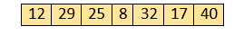
Now, for the first position in the sorted array, the entire array is to be scanned sequentially.
At present, 12 is stored at the first position, after searching the entire array, it is found that 8 is the smallest value.
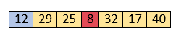
So, swap 12 with 8. After the first iteration, 8 will appear at the first position in the sorted array.
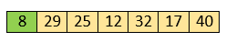
For the second position, where 29 is stored presently, we again sequentially scan the rest of the items of unsorted array. After scanning, we find that 12 is the second lowest element in the array that should be appeared at second position.
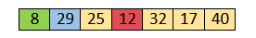
Now, swap 29 with 12. After the second iteration, 12 will appear at the second position in the sorted array. So, after two iterations, the two smallest values are placed at the beginning in a sorted way.
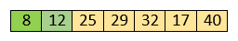
The same process is applied to the rest of the array elements. Now, we are showing a pictorial representation of the entire sorting process.
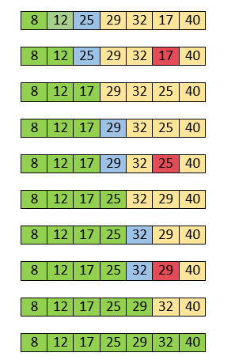
Now, the array is completely sorted.

Quick Sort Algorithm
The working procedure of Quicksort is also simple. This article will be very helpful and interesting to students as they might face quicksort as a question in their examinations. So, it is important to discuss the topic.
Sorting is a way of arranging items in a systematic manner. Quicksort is the widely used sorting algorithm that makes n log n comparisons in average case for sorting an array of n elements. It is a faster and highly efficient sorting algorithm. This algorithm follows the divide and conquer approach. Divide and conquer is a technique of breaking down the algorithms into subproblems, then solving the subproblems, and combining the results back together to solve the original problem.
Divide: In Divide, first pick a pivot element. After that, partition or rearrange the array into two sub-arrays such that each element in the left sub-array is less than or equal to the pivot element and each element in the right sub-array is larger than the pivot element.
Conquer: Recursively, sort two subarrays with Quicksort.
Combine: Combine the already sorted array.
Quicksort picks an element as pivot, and then it partitions the given array around the picked pivot element. In quick sort, a large array is divided into two arrays in which one holds values that are smaller than the specified value (Pivot), and another array holds the values that are greater than the pivot.
After that, left and right sub-arrays are also partitioned using the same approach. It will continue until the single element remains in the sub-array.
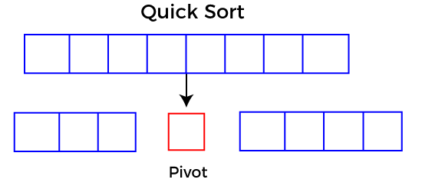

Choosing the pivot
Picking a good pivot is necessary for the fast implementation of quicksort. However, it is typical to determine a good pivot. Some of the ways of choosing a pivot are as follows -
- Pivot can be random, i.e. select the random pivot from the given array.
- Pivot can either be the rightmost element of the leftmost element of the given array.
- Select median as the pivot element.

Algorithm
Algorithm:
- QUICKSORT (array A, start, end)
- {
- 1 if (start < end)
- 2 {
- 3 p = partition(A, start, end)
- 4 QUICKSORT (A, start, p - 1)
- 5 QUICKSORT (A, p + 1, end)
- 6 }
- }
Partition Algorithm:
The partition algorithm rearranges the sub-arrays in a place.
- PARTITION (array A, start, end)
- {
- 1 pivot ? A[end]
- 2 i ? start-1
- 3 for j ? start to end -1 {
- 4 do if (A[j] < pivot) {
- 5 then i ? i + 1
- 6 swap A[i] with A[j]
- 7 }}
- 8 swap A[i+1] with A[end]
- 9 return i+1
- }

Working of Quick Sort Algorithm
Now, let's see the working of the Quicksort Algorithm.
To understand the working of quick sort, let's take an unsorted array. It will make the concept more clear and understandable.
Let the elements of array are -
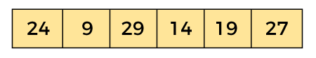
In the given array, we consider the leftmost element as pivot. So, in this case, a[left] = 24, a[right] = 27 and a[pivot] = 24.
Since, pivot is at left, so algorithm starts from right and move towards left.
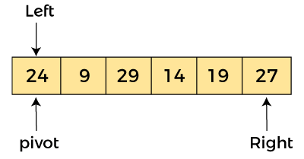
Now, a[pivot] < a[right], so algorithm moves forward one position towards left, i.e. -
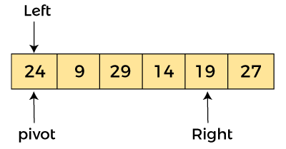
Now, a[left] = 24, a[right] = 19, and a[pivot] = 24.
Because, a[pivot] > a[right], so, algorithm will swap a[pivot] with a[right], and pivot moves to right, as -
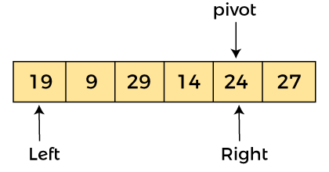
Now, a[left] = 19, a[right] = 24, and a[pivot] = 24. Since, pivot is at right, so algorithm starts from left and moves to right.
As a[pivot] > a[left], so algorithm moves one position to right as -
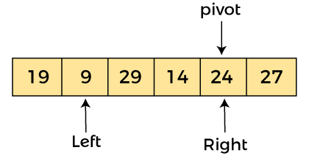
Now, a[left] = 9, a[right] = 24, and a[pivot] = 24. As a[pivot] > a[left], so algorithm moves one position to right as -
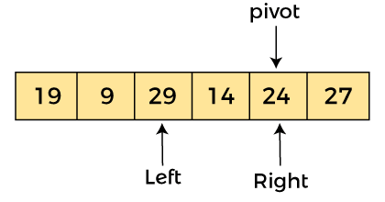
Now, a[left] = 29, a[right] = 24, and a[pivot] = 24. As a[pivot] < a[left], so, swap a[pivot] and a[left], now pivot is at left, i.e. -
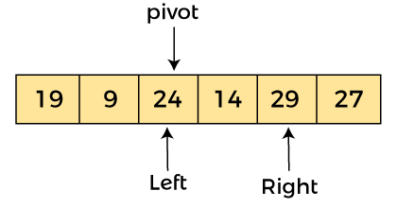
Since, pivot is at left, so algorithm starts from right, and move to left. Now, a[left] = 24, a[right] = 29, and a[pivot] = 24. As a[pivot] < a[right], so algorithm moves one position to left, as -
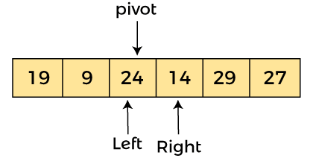
Now, a[pivot] = 24, a[left] = 24, and a[right] = 14. As a[pivot] > a[right], so, swap a[pivot] and a[right], now pivot is at right, i.e. -
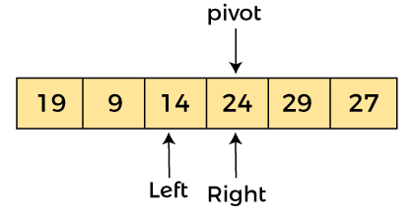
Now, a[pivot] = 24, a[left] = 14, and a[right] = 24. Pivot is at right, so the algorithm starts from left and move to right.
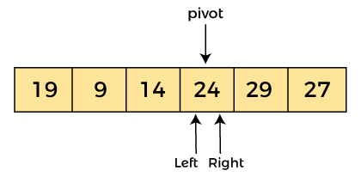
Now, a[pivot] = 24, a[left] = 24, and a[right] = 24. So, pivot, left and right are pointing the same element. It represents the termination of procedure.
Element 24, which is the pivot element is placed at its exact position.
Elements that are right side of element 24 are greater than it, and the elements that are left side of element 24 are smaller than it.
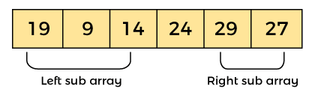
Now, in a similar manner, quick sort algorithm is separately applied to the left and right sub-arrays. After sorting gets done, the array will be -
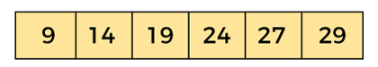

Merge Sort Algorithm
Merge sort is the sorting technique that follows the divide and conquer approach. This article will be very helpful and interesting to students as they might face merge sort as a question in their examinations. In coding or technical interviews for software engineers, sorting algorithms are widely asked. So, it is important to discuss the topic.
Merge sort is similar to the quick sort algorithm as it uses the divide and conquer approach to sort the elements. It is one of the most popular and efficient sorting algorithm. It divides the given list into two equal halves, calls itself for the two halves and then merges the two sorted halves. We have to define the merge() function to perform the merging.
The sub-lists are divided again and again into halves until the list cannot be divided further. Then we combine the pair of one element lists into two-element lists, sorting them in the process. The sorted two-element pairs is merged into the four-element lists, and so on until we get the sorted list.
Now, let's see the algorithm of merge sort.

Algorithm
In the following algorithm, arr is the given array, beg is the starting element, and end is the last element of the array.
- MERGE_SORT(arr, beg, end)

- if beg < end
- set mid = (beg + end)/2
- MERGE_SORT(arr, beg, mid)
- MERGE_SORT(arr, mid + 1, end)
- MERGE (arr, beg, mid, end)
- end of if

- END MERGE_SORT
The important part of the merge sort is the MERGE function. This function performs the merging of two sorted sub-arrays that are A[beg…mid] and A[mid+1…end], to build one sorted array A[beg…end]. So, the inputs of the MERGE function are A[], beg, mid, and end.

Working of Merge sort Algorithm
Now, let's see the working of merge sort Algorithm.
To understand the working of the merge sort algorithm, let's take an unsorted array. It will be easier to understand the merge sort via an example.
Let the elements of array are -
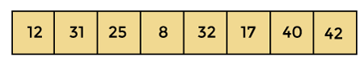
According to the merge sort, first divide the given array into two equal halves. Merge sort keeps dividing the list into equal parts until it cannot be further divided.
As there are eight elements in the given array, so it is divided into two arrays of size 4.
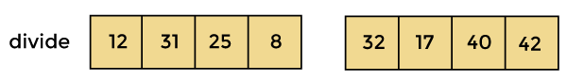
Now, again divide these two arrays into halves. As they are of size 4, so divide them into new arrays of size 2.
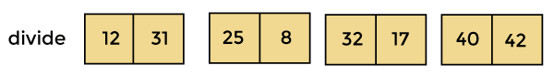
Now, again divide these arrays to get the atomic value that cannot be further divided.
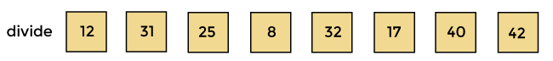
Now, combine them in the same manner they were broken.
In combining, first compare the element of each array and then combine them into another array in sorted order.
So, first compare 12 and 31, both are in sorted positions. Then compare 25 and 8, and in the list of two values, put 8 first followed by 25. Then compare 32 and 17, sort them and put 17 first followed by 32. After that, compare 40 and 42, and place them sequentially.
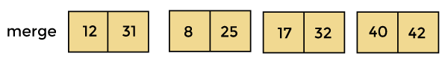
In the next iteration of combining, now compare the arrays with two data values and merge them into an array of found values in sorted order.
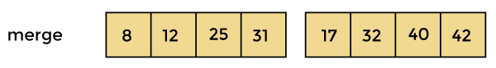
Now, there is a final merging of the arrays. After the final merging of above arrays, the array will look like -
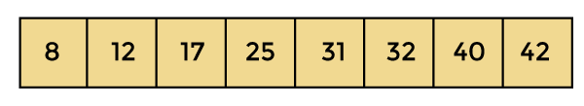
Now, the array is completely sorted.

Radix Sort Algorithm
Radix sort is the linear sorting algorithm that is used for integers. In Radix sort, there is digit by digit sorting is performed that is started from the least significant digit to the most significant digit.
The process of radix sort works similar to the sorting of students names, according to the alphabetical order. In this case, there are 26 radix formed due to the 26 alphabets in English. In the first pass, the names of students are grouped according to the ascending order of the first letter of their names. After that, in the second pass, their names are grouped according to the ascending order of the second letter of their name. And the process continues until we find the sorted list.
Now, let's see the algorithm of Radix sort.

Algorithm
- radixSort(arr)
- max = largest element in the given array
- d = number of digits in the largest element (or, max)
- Now, create d buckets of size 0 - 9
- for i -> 0 to d
- sort the array elements using counting sort (or any stable sort) according to the digits at
- the ith place

Working of Radix sort Algorithm
Now, let's see the working of Radix sort Algorithm.
The steps used in the sorting of radix sort are listed as follows -
- First, we have to find the largest element (suppose max) from the given array. Suppose 'x' be the number of digits in max. The 'x' is calculated because we need to go through the significant places of all elements.
- After that, go through one by one each significant place. Here, we have to use any stable sorting algorithm to sort the digits of each significant place.
Now let's see the working of radix sort in detail by using an example. To understand it more clearly, let's take an unsorted array and try to sort it using radix sort. It will make the explanation clearer and easier.
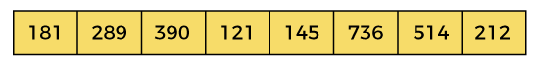
In the given array, the largest element is 736 that have 3 digits in it. So, the loop will run up to three times (i.e., to the hundreds place). That means three passes are required to sort the array.
Now, first sort the elements on the basis of unit place digits (i.e., x = 0). Here, we are using the counting sort algorithm to sort the elements.

Pass 1:
In the first pass, the list is sorted on the basis of the digits at 0's place.
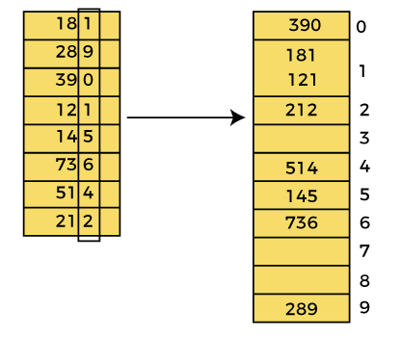
After the first pass, the array elements are -
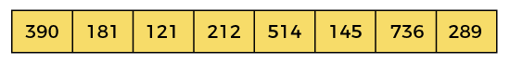

Pass 2:
In this pass, the list is sorted on the basis of the next significant digits (i.e., digits at 10th place).
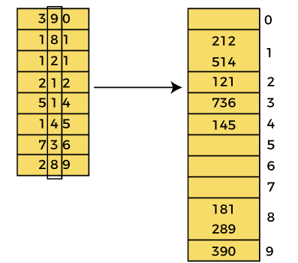
After the second pass, the array elements are -
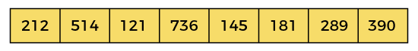

Pass 3:
In this pass, the list is sorted on the basis of the next significant digits (i.e., digits at 100th place).
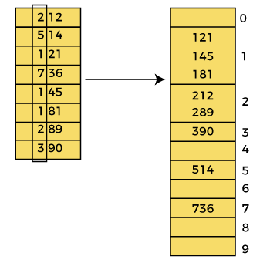
After the third pass, the array elements are -
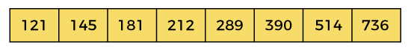
Now, the array is sorted in ascending order.

Heap Sort Algorithm
Heap sort processes the elements by creating the min-heap or max-heap using the elements of the given array. Min-heap or max-heap represents the ordering of array in which the root element represents the minimum or maximum element of the array.
Heap sort basically recursively performs two main operations -
- Build a heap H, using the elements of array.
- Repeatedly delete the root element of the heap formed in 1st phase.
Before knowing more about the heap sort, let's first see a brief description of Heap.

What is a heap?
A heap is a complete binary tree, and the binary tree is a tree in which the node can have the utmost two children. A complete binary tree is a binary tree in which all the levels except the last level, i.e., leaf node, should be completely filled, and all the nodes should be left-justified.

What is heap sort?
Heapsort is a popular and efficient sorting algorithm. The concept of heap sort is to eliminate the elements one by one from the heap part of the list, and then insert them into the sorted part of the list.
Heapsort is the in-place sorting algorithm.
Now, let's see the algorithm of heap sort.

Algorithm
- HeapSort(arr)
- BuildMaxHeap(arr)
- for i = length(arr) to 2
- swap arr[1] with arr[i]
- heap_size[arr] = heap_size[arr] ? 1
- MaxHeapify(arr,1)
- End
BuildMaxHeap(arr)
- BuildMaxHeap(arr)
- heap_size(arr) = length(arr)
- for i = length(arr)/2 to 1
- MaxHeapify(arr,i)
- End
MaxHeapify(arr,i)
- MaxHeapify(arr,i)
- L = left(i)
- R = right(i)
- if L ? heap_size[arr] and arr[L] > arr[i]
- largest = L
- else
- largest = i
- if R ? heap_size[arr] and arr[R] > arr[largest]
- largest = R
- if largest != i
- swap arr[i] with arr[largest]
- MaxHeapify(arr,largest)
- End

Working of Heap sort Algorithm
Now, let's see the working of the Heapsort Algorithm.
In heap sort, basically, there are two phases involved in the sorting of elements. By using the heap sort algorithm, they are as follows -
- The first step includes the creation of a heap by adjusting the elements of the array.
- After the creation of heap, now remove the root element of the heap repeatedly by shifting it to the end of the array, and then store the heap structure with the remaining elements.
Now let's see the working of heap sort in detail by using an example. To understand it more clearly, let's take an unsorted array and try to sort it using heap sort. It will make the explanation clearer and easier.
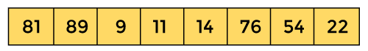
First, we have to construct a heap from the given array and convert it into max heap.
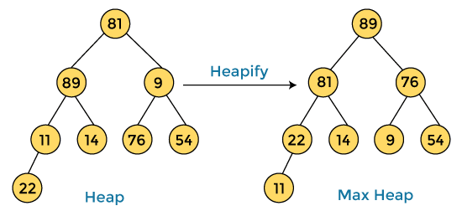
After converting the given heap into max heap, the array elements are -
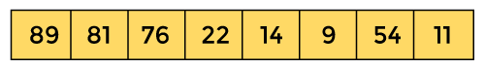
Next, we have to delete the root element (89) from the max heap. To delete this node, we have to swap it with the last node, i.e. (11). After deleting the root element, we again have to heapify it to convert it into max heap.
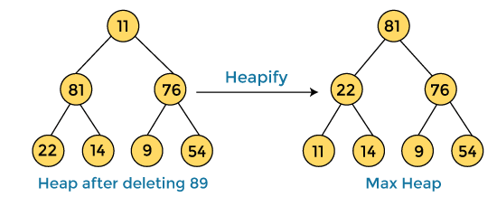
After swapping the array element 89 with 11, and converting the heap into max-heap, the elements of array are -
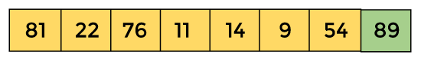
In the next step, again, we have to delete the root element (81) from the max heap. To delete this node, we have to swap it with the last node, i.e. (54). After deleting the root element, we again have to heapify it to convert it into max heap.
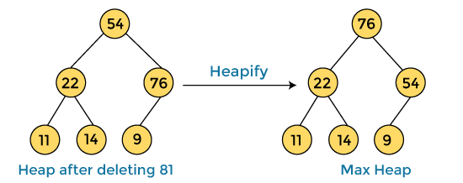
After swapping the array element 81 with 54 and converting the heap into max-heap, the elements of array are -
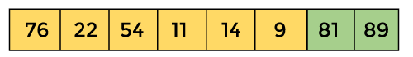
In the next step, we have to delete the root element (76) from the max heap again. To delete this node, we have to swap it with the last node, i.e. (9). After deleting the root element, we again have to heapify it to convert it into max heap.
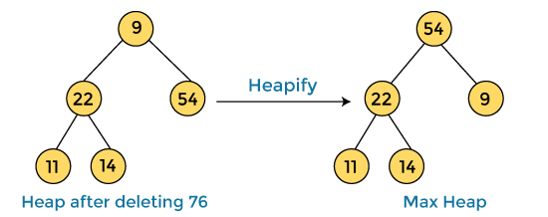
After swapping the array element 76 with 9 and converting the heap into max-heap, the elements of array are -
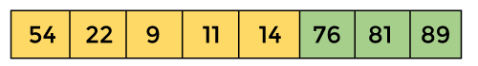
In the next step, again we have to delete the root element (54) from the max heap. To delete this node, we have to swap it with the last node, i.e. (14). After deleting the root element, we again have to heapify it to convert it into max heap.
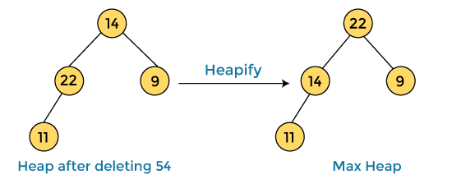
After swapping the array element 54 with 14 and converting the heap into max-heap, the elements of array are -
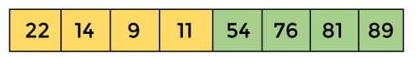
In the next step, again we have to delete the root element (22) from the max heap. To delete this node, we have to swap it with the last node, i.e. (11). After deleting the root element, we again have to heapify it to convert it into max heap.
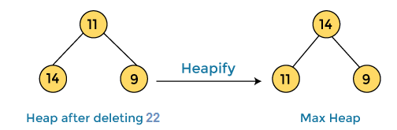
After swapping the array element 22 with 11 and converting the heap into max-heap, the elements of array are -
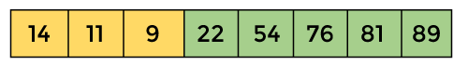
In the next step, again we have to delete the root element (14) from the max heap. To delete this node, we have to swap it with the last node, i.e. (9). After deleting the root element, we again have to heapify it to convert it into max heap.
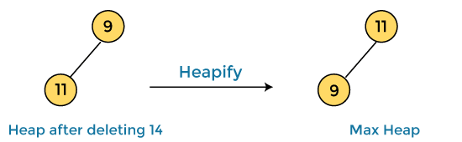
After swapping the array element 14 with 9 and converting the heap into max-heap, the elements of array are -
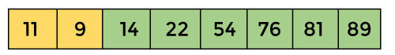
In the next step, again we have to delete the root element (11) from the max heap. To delete this node, we have to swap it with the last node, i.e. (9). After deleting the root element, we again have to heapify it to convert it into max heap.
After swapping the array element 11 with 9, the elements of array are -
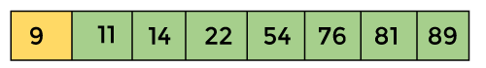
Now, heap has only one element left. After deleting it, heap will be empty.
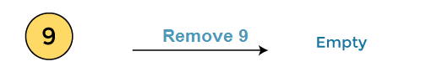
After completion of sorting, the array elements are -
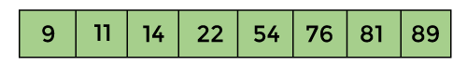
Now, the array is completely sorted.

Binary Tree
The Binary tree means that the node can have maximum two children. Here, binary name itself suggests that 'two'; therefore, each node can have either 0, 1 or 2 children.
Let's understand the binary tree through an example.
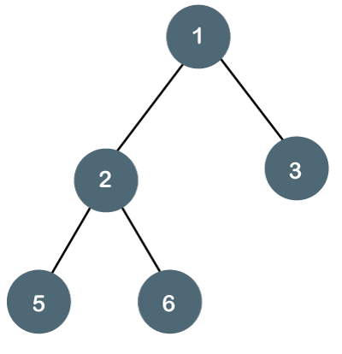
The above tree is a binary tree because each node contains the utmost two children. The logical representation of the above tree is given below:
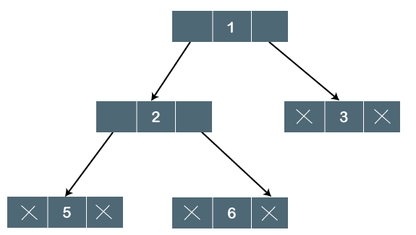
In the above tree, node 1 contains two pointers, i.e., left and a right pointer pointing to the left and right node respectively. The node 2 contains both the nodes (left and right node); therefore, it has two pointers (left and right). The nodes 3, 5 and 6 are the leaf nodes, so all these nodes contain NULL pointer on both left and right parts.

Properties of Binary Tree
- At each level of i, the maximum number of nodes is 2^{i}.
- The height of the tree is defined as the longest path from the root node to the leaf node. The tree which is shown above has a height equal to 3. Therefore, the maximum number of nodes at height 3 is equal to (1+2+4+8) = 15. In general, the maximum number of nodes possible at height h is (2⁰ + 2¹ + 2²+….2^{h}) = 2^{h+1} -1.
- The minimum number of nodes possible at height h is equal to h+1.
- If the number of nodes is minimum, then the height of the tree would be maximum. Conversely, if the number of nodes is maximum, then the height of the tree would be minimum.
If there are 'n' number of nodes in the binary tree.
The minimum height can be computed as:
As we know that,
n = 2^{h+1} -1
n+1 = 2^{h+1}
Taking log on both the sides,
log₂(n+1) = log2(2^{h+1})
log₂(n+1) = h+1
h = log₂(n+1) - 1
The maximum height can be computed as:
As we know that,
n = h+1
h= n-1

Types of Binary Tree
There are four types of Binary tree:
- Full/ proper/ strict Binary tree
- Complete Binary tree
- Perfect Binary tree
- Degenerate Binary tree
- Balanced Binary tree
1. Full/ proper/ strict Binary tree
The full binary tree is also known as a strict binary tree. The tree can only be considered as the full binary tree if each node must contain either 0 or 2 children. The full binary tree can also be defined as the tree in which each node must contain 2 children except the leaf nodes.
Let's look at the simple example of the Full Binary tree.
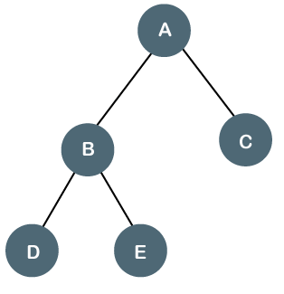
In the above tree, we can observe that each node is either containing zero or two children; therefore, it is a Full Binary tree.
Properties of Full Binary Tree
- The number of leaf nodes is equal to the number of internal nodes plus 1. In the above example, the number of internal nodes is 5; therefore, the number of leaf nodes is equal to 6.
- The maximum number of nodes is the same as the number of nodes in the binary tree, i.e., 2^{h+1} -1.
- The minimum number of nodes in the full binary tree is 2*h-1.
- The minimum height of the full binary tree is log₂(n+1) - 1.
- The maximum height of the full binary tree can be computed as:
n= 2*h - 1
n+1 = 2*h
h = n+1/2
Complete Binary Tree
The complete binary tree is a tree in which all the nodes are completely filled except the last level. In the last level, all the nodes must be as left as possible. In a complete binary tree, the nodes should be added from the left.
Let's create a complete binary tree.
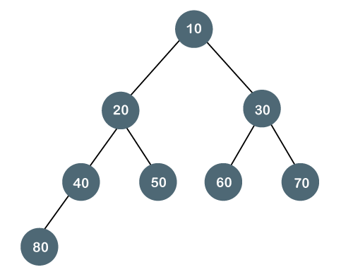
The above tree is a complete binary tree because all the nodes are completely filled, and all the nodes in the last level are added at the left first.
Properties of Complete Binary Tree
- The maximum number of nodes in complete binary tree is 2^{h+1} - 1.
- The minimum number of nodes in complete binary tree is 2^{h}.
- The minimum height of a complete binary tree is log₂(n+1) - 1.
- The maximum height of a complete binary tree is
Perfect Binary Tree
A tree is a perfect binary tree if all the internal nodes have 2 children, and all the leaf nodes are at the same level.
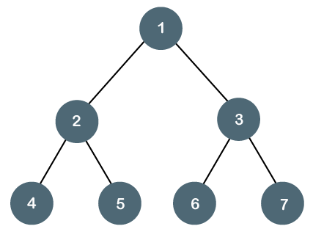
Let's look at a simple example of a perfect binary tree.
The below tree is not a perfect binary tree because all the leaf nodes are not at the same level.
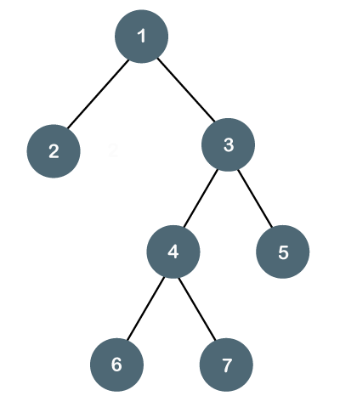

Note: All the perfect binary trees are the complete binary trees as well as the full binary tree, but vice versa is not true, i.e., all complete binary trees and full binary trees are the perfect binary trees.

Degenerate Binary Tree
The degenerate binary tree is a tree in which all the internal nodes have only one children.
Let's understand the Degenerate binary tree through examples.
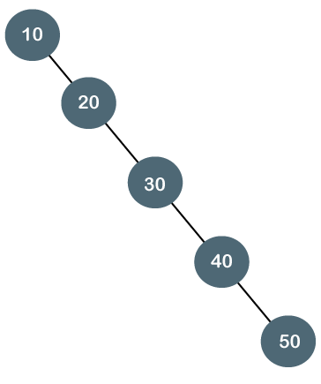
The above tree is a degenerate binary tree because all the nodes have only one child. It is also known as a right-skewed tree as all the nodes have a right child only.
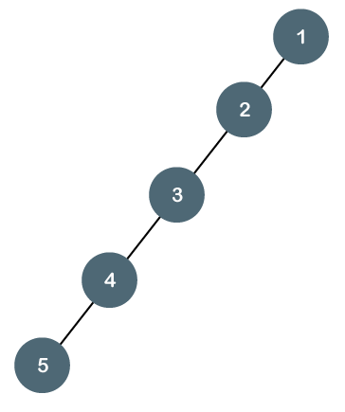
The above tree is also a degenerate binary tree because all the nodes have only one child. It is also known as a left-skewed tree as all the nodes have a left child only.
Balanced Binary Tree
The balanced binary tree is a tree in which both the left and right trees differ by atmost 1. For example, AVL and Red-Black trees are balanced binary tree.
Let's understand the balanced binary tree through examples.
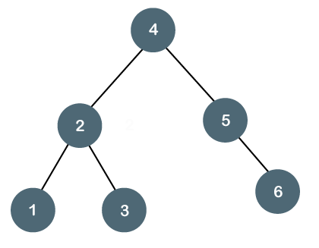
The above tree is a balanced binary tree because the difference between the left subtree and right subtree is zero.
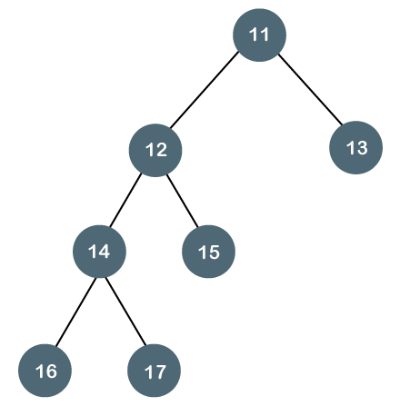
The above tree is not a balanced binary tree because the difference between the left subtree and the right subtree is greater than 1.

Binary Search tree
In this article, we will discuss the Binary search tree. This article will be very helpful and informative to the students with technical background as it is an important topic of their course.
Before moving directly to the binary search tree, let's first see a brief description of the tree.

What is a tree?
A tree is a kind of data structure that is used to represent the data in hierarchical form. It can be defined as a collection of objects or entities called as nodes that are linked together to simulate a hierarchy. Tree is a non-linear data structure as the data in a tree is not stored linearly or sequentially.
Now, let's start the topic, the Binary Search tree.

What is a Binary Search tree?
A binary search tree follows some order to arrange the elements. In a Binary search tree, the value of left node must be smaller than the parent node, and the value of right node must be greater than the parent node. This rule is applied recursively to the left and right subtrees of the root.
Let's understand the concept of Binary search tree with an example.
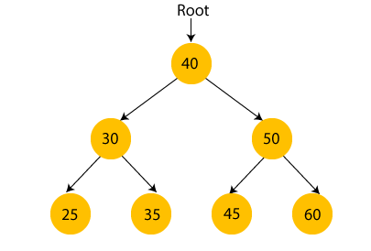
In the above figure, we can observe that the root node is 40, and all the nodes of the left subtree are smaller than the root node, and all the nodes of the right subtree are greater than the root node.
Similarly, we can see the left child of root node is greater than its left child and smaller than its right child. So, it also satisfies the property of binary search tree. Therefore, we can say that the tree in the above image is a binary search tree.
Suppose if we change the value of node 35 to 55 in the above tree, check whether the tree will be binary search tree or not.
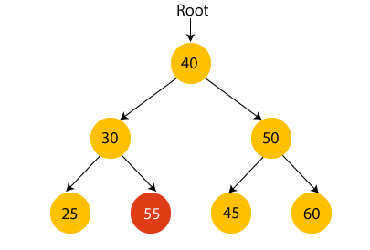
In the above tree, the value of root node is 40, which is greater than its left child 30 but smaller than right child of 30, i.e., 55. So, the above tree does not satisfy the property of Binary search tree. Therefore, the above tree is not a binary search tree.

Advantages of Binary search tree
- Searching an element in the Binary search tree is easy as we always have a hint that which subtree has the desired element.
- As compared to array and linked lists, insertion and deletion operations are faster in BST.

Example of creating a binary search tree
Now, let's see the creation of binary search tree using an example.
Suppose the data elements are - 45, 15, 79, 90, 10, 55, 12, 20, 50
- First, we have to insert 45 into the tree as the root of the tree.
- Then, read the next element; if it is smaller than the root node, insert it as the root of the left subtree, and move to the next element.
- Otherwise, if the element is larger than the root node, then insert it as the root of the right subtree.
Now, let's see the process of creating the Binary search tree using the given data element. The process of creating the BST is shown below -
Step 1 - Insert 45.
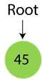
Step 2 - Insert 15.
As 15 is smaller than 45, so insert it as the root node of the left subtree.
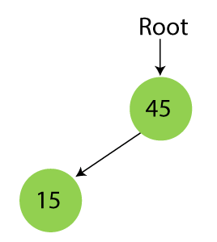
Step 3 - Insert 79.
As 79 is greater than 45, so insert it as the root node of the right subtree.
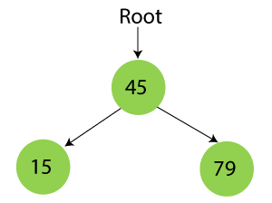
Step 4 - Insert 90.
90 is greater than 45 and 79, so it will be inserted as the right subtree of 79.
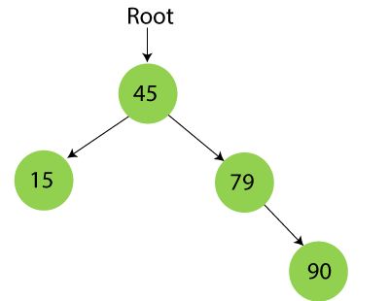
Step 5 - Insert 10.
10 is smaller than 45 and 15, so it will be inserted as a left subtree of 15.
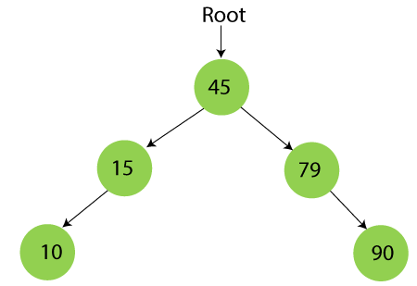
Step 6 - Insert 55.
55 is larger than 45 and smaller than 79, so it will be inserted as the left subtree of 79.
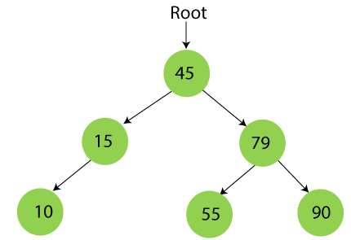
Step 7 - Insert 12.
12 is smaller than 45 and 15 but greater than 10, so it will be inserted as the right subtree of 10.
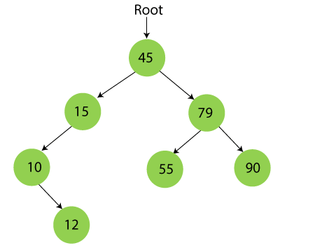
Step 8 - Insert 20.
20 is smaller than 45 but greater than 15, so it will be inserted as the right subtree of 15.
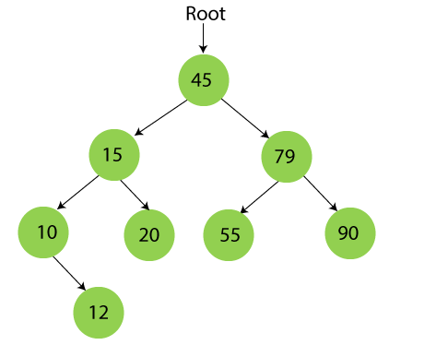
Step 9 - Insert 50.
50 is greater than 45 but smaller than 79 and 55. So, it will be inserted as a left subtree of 55.
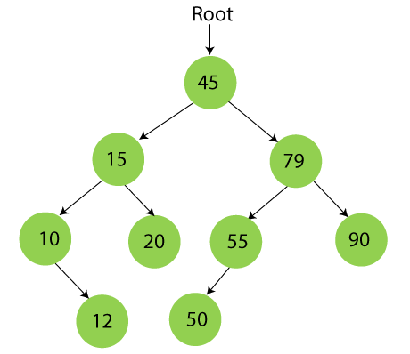
Now, the creation of binary search tree is completed. After that, let's move towards the operations that can be performed on Binary search tree.
We can perform insert, delete and search operations on the binary search tree.
Let's understand how a search is performed on a binary search tree.

Searching in Binary search tree
Searching means to find or locate a specific element or node in a data structure. In Binary search tree, searching a node is easy because elements in BST are stored in a specific order. The steps of searching a node in Binary Search tree are listed as follows -
- First, compare the element to be searched with the root element of the tree.
- If root is matched with the target element, then return the node's location.
- If it is not matched, then check whether the item is less than the root element, if it is smaller than the root element, then move to the left subtree.
- If it is larger than the root element, then move to the right subtree.
- Repeat the above procedure recursively until the match is found.
- If the element is not found or not present in the tree, then return NULL.
Now, let's understand the searching in binary tree using an example. We are taking the binary search tree formed above. Suppose we have to find node 20 from the below tree.
Step1:
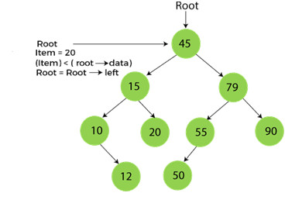
Step2:
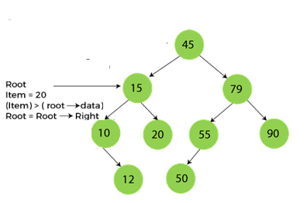
Step3:
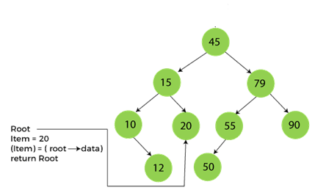
Now, let's see the algorithm to search an element in the Binary search tree.

Algorithm to search an element in Binary search tree
- Search (root, item)
- Step 1 - if (item = root → data) or (root = NULL)
- return root
- else if (item < root → data)
- return Search(root → left, item)
- else
- return Search(root → right, item)
- END if
- Step 2 - END
Now let's understand how the deletion is performed on a binary search tree. We will also see an example to delete an element from the given tree.

Deletion in Binary Search tree
In a binary search tree, we must delete a node from the tree by keeping in mind that the property of BST is not violated. To delete a node from BST, there are three possible situations occur -
- The node to be deleted is the leaf node, or,
- The node to be deleted has only one child, and,
- The node to be deleted has two children
We will understand the situations listed above in detail.
When the node to be deleted is the leaf node
It is the simplest case to delete a node in BST. Here, we have to replace the leaf node with NULL and simply free the allocated space.
We can see the process to delete a leaf node from BST in the below image. In below image, suppose we have to delete node 90, as the node to be deleted is a leaf node, so it will be replaced with NULL, and the allocated space will free.
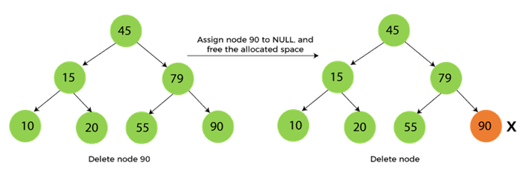
When the node to be deleted has only one child
In this case, we have to replace the target node with its child, and then delete the child node. It means that after replacing the target node with its child node, the child node will now contain the value to be deleted. So, we simply have to replace the child node with NULL and free up the allocated space.
We can see the process of deleting a node with one child from BST in the below image. In the below image, suppose we have to delete the node 79, as the node to be deleted has only one child, so it will be replaced with its child 55.
So, the replaced node 79 will now be a leaf node that can be easily deleted.
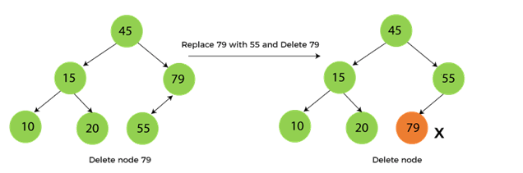
When the node to be deleted has two children
This case of deleting a node in BST is a bit complex among other two cases. In such a case, the steps to be followed are listed as follows -
- First, find the inorder successor of the node to be deleted.
- After that, replace that node with the inorder successor until the target node is placed at the leaf of tree.
- And at last, replace the node with NULL and free up the allocated space.
The inorder successor is required when the right child of the node is not empty. We can obtain the inorder successor by finding the minimum element in the right child of the node.
We can see the process of deleting a node with two children from BST in the below image. In the below image, suppose we have to delete node 45 that is the root node, as the node to be deleted has two children, so it will be replaced with its inorder successor. Now, node 45 will be at the leaf of the tree so that it can be deleted easily.
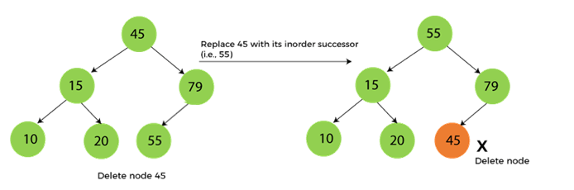
Now let's understand how insertion is performed on a binary search tree.

Insertion in Binary Search tree
A new key in BST is always inserted at the leaf. To insert an element in BST, we have to start searching from the root node; if the node to be inserted is less than the root node, then search for an empty location in the left subtree. Else, search for the empty location in the right subtree and insert the data. Insert in BST is similar to searching, as we always have to maintain the rule that the left subtree is smaller than the root, and right subtree is larger than the root.
Now, let's see the process of inserting a node into BST using an example.
